
www.globalsight.com

GlobalSight Xliff
User Guide

Version 1.2
Open source initiative for
managing, translating &
delivering global content

More details available at: http://www.globalsight.com

Overview
Xliff was developed as a replacement for RTF files that the translator currently uses when doing translation offline with both download and upload functions.
Work Offline with Xliff format files
After the translator accepts an activity, he can select doing the translation offline by going to “Work Offline”.
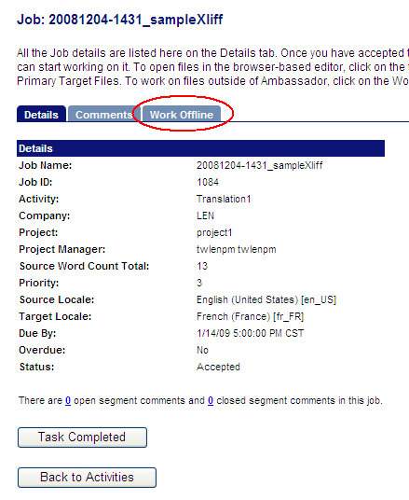

1. Download
In download page, select files under “Primary Target Files” and set “Xliff 1.2” in the Format option under Download Options. (Currently Xliff version 1.2 is supported). Then click “Start Download” to download the selected files in xliff format.
1.1 Download with "Annotations" as the "Insert resources as" option

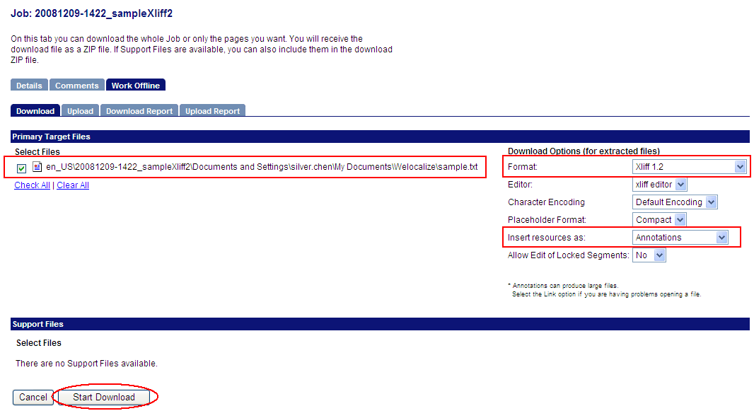

After download process is finished, save the downloaded zip file to local machine and unzip it. Go to the “inbox” folder and the file(s) are listed in xliff format with xlf suffix.

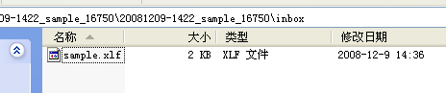

In this example, the content in the xliff file sample.xlf is:
<?xml version="1.0" encoding="UTF-8"?>
<xliff version="1.2">
<file original="sample.txt" source-language="en_US" target-language="fr_FR" datatype="plaintext">
<header>
<note>
# GlobalSight Download File
# User name:lenanyone
# Accept time:12/12/2008 14:23:22
# Encoding:UTF-16LE
# Document Format:plaintext
# Placeholder Format:PTAG-COMPACT
# Source Locale:en_US
# Target Locale:fr_FR
# Page ID:1096
# Workflow ID:16748
# Task ID:16750
# Exact Match word count:7
# Fuzzy Match word count:13
# No Match word count:0
# Edit all:No
</note>
</header>
<body>
<trans-unit id="1216" extradata="No Match.">
<source>We had a plan on this.
</source>
<target>We had a plan on this.
</target>
</trans-unit>
<trans-unit id="1217" extradata="Fuzzy Matches are available. (see also index.html)">
<source>Glad hearing your idea.
</source>
<target>Glad hearing your idea.
</target>
<alt-trans match-quality="89">
<source>Glad hearing your idea.
</source>
<target>很高兴听到你们的想法 </target>
</alt-trans>
</trans-unit>
<trans-unit id="1218" extradata="Fuzzy Matches are available. (see also index.html)">
<source>Have seats please.
</source>
<target>Have seats please.
</target>
<alt-trans match-quality="76">
<source>Have seats please.
</source>
<target>请坐</target>
</alt-trans>
</trans-unit>
<trans-unit id="1219" extradata="DO NOT TRANSLATE OR MODIFY (Locked).">
<source>We will have a plan on this.
</source>
<target>我们会有个计划
</target>
<alt-trans match-quality="100">
<source>We will have a plan on this.
</source>
<target>我们会有个计划
</target>
</alt-trans>
</trans-unit>
</body>
</file>
</xliff>

Note: In the sample.xlf,
- Attribute extradata contains the values of match types which indicate the leverage match result for the segments.
- The content marked red between source element shows the source segments from the source file.
- The content marked blue between target element shows the target segments. They might have been translated automatically with 100% exact matches in TM and translated by other translator before, otherwise, they are kept the same as the source segments.
- Target segments marked blue above are the only content that needs to be edited for translation. Editing any other content may cause upload failure.
- Element alt-trans indicates the match quality and match result in the related TM for each source segment. The content marked green in the target element is the match result in the TM for the source segment. It is useful for a translator to do translation with these TM leverage results referenced. The segment which has a 100% exact match is translated automatically like segment with trans-unit id 1219 shown above.

1.2 Download with TMX File (take "TMX File - both" as an example) as the "Insert resources as" option
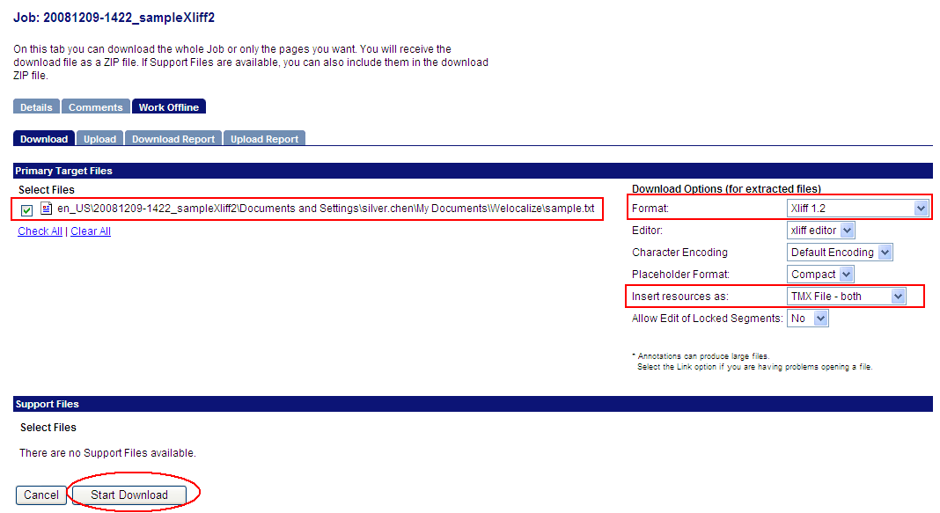

Unzip the downloaded file and get the xliff file in the inbox folder. Compared with the xliff file downloaded in the first way, it has the same content except for alt-trans element. To get the leverage results by the TM, you can refer to the downloaded TMX file(s) which are located at tmx folder at the same level with inbox folder.

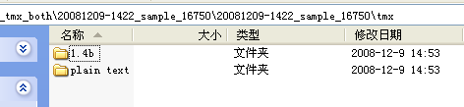

Because the “Insert resources as” option is selected “TMX File – both”, there are two versions of TMX files downloaded. One is version 1.4 in 1.4b folder and the other is version 1.1 in plain text folder. They have the same content of leverage results from TM. And they can be used as reference like alt-trans element in the first downloading way when translator is doing translation on the xliff file. One example for the TMX file version 1.4 is:
<?xml version="1.0" encoding="UTF-8" ?>
<!DOCTYPE tmx SYSTEM "tmx14.dtd" >
<tmx version="1.4">
<header creationtool="Transware Ambassador" creationtoolversion="6.0" segtype="sentence" o-tmf="gxml" adminlang="EN-US" srclang="en_US" datatype="html" >
</header>
<body>
<tu creationdate="20081209T000000Z" creationid="lenanyone">
<tuv xml:lang="en_US">
<seg>Glad hearing your ideas.
</seg></tuv>
<tuv xml:lang="fr_FR">
<seg>很高兴听到你们的想法 </seg></tuv>
</tu>
<tu creationdate="20081209T000000Z" creationid="lenanyone">
<tuv xml:lang="en_US">
<seg>Have a seat please.</seg></tuv>
<tuv xml:lang="fr_FR">
<seg>请坐</seg></tuv>
</tu>
<tu creationdate="20081209T145306Z" creationid="lenanyone">
<tuv xml:lang="en_US">
<seg>We will have a plan on this.
</seg></tuv>
<tuv xml:lang="fr_FR">
<seg>我们会有个计划
</seg></tuv>
</tu>
</body>
</tmx>

2. Translate
- Since the xliff file is text format, it can be opened and edited in any text editor. However, as mentioned above, only the content in target element marked blue needs to be edited/translated by translator.
- A better way to avoid modifying any content that is not allowed to is to translate with Xliff editor which is a third party tool specially for editing the xliff files.

Below is a free Xliff editor called Transolution Xliff Editor. Steps below are showing how to translate an xliff file with it. (Since the Xliff editor only cares about the content of source segment marked red and target segments marked blue above, two kinds of downloaded xliff files have almost the same steps for translation in Xliff editor. Taking one as an example)

2.1 Open an Xliff file(sample.xlf) in the editor. (Note: The path of the xliff file can not contain double byte characters like Chinese characters, or it can not be opened with this editor)

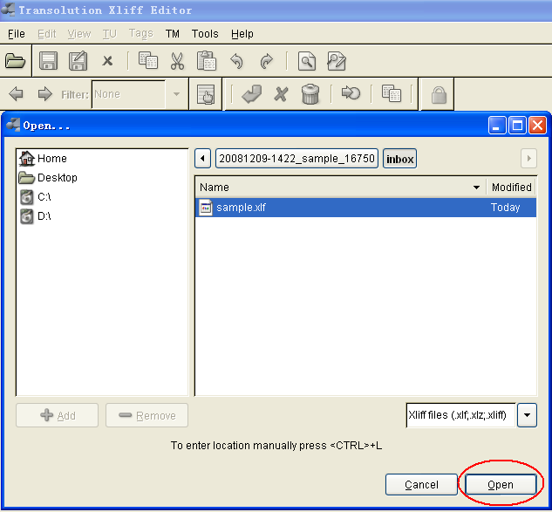

2.2 Content of the xliff file displays in the editor.

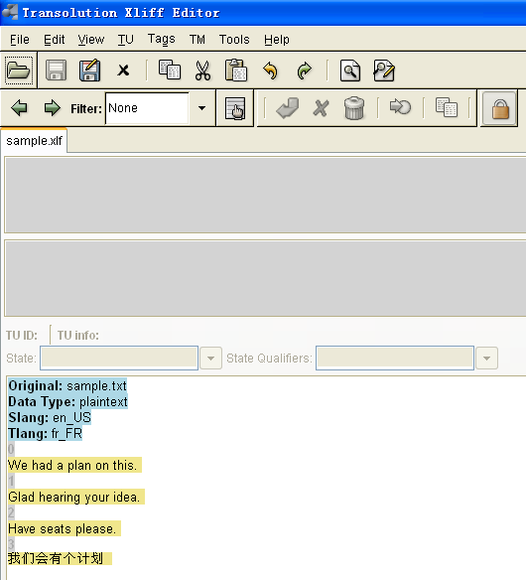

2.3 Select a segment and open it for translation.

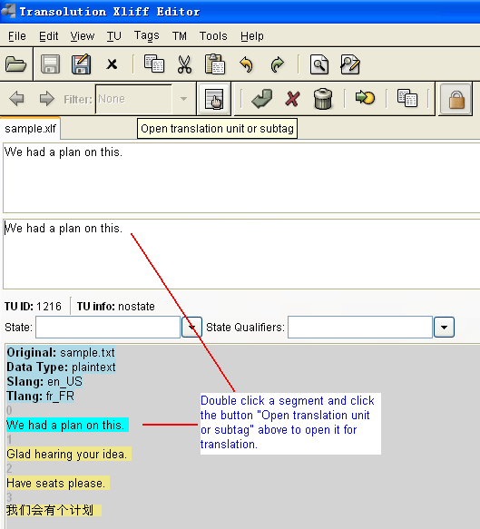

2.4 Edit the target segment.

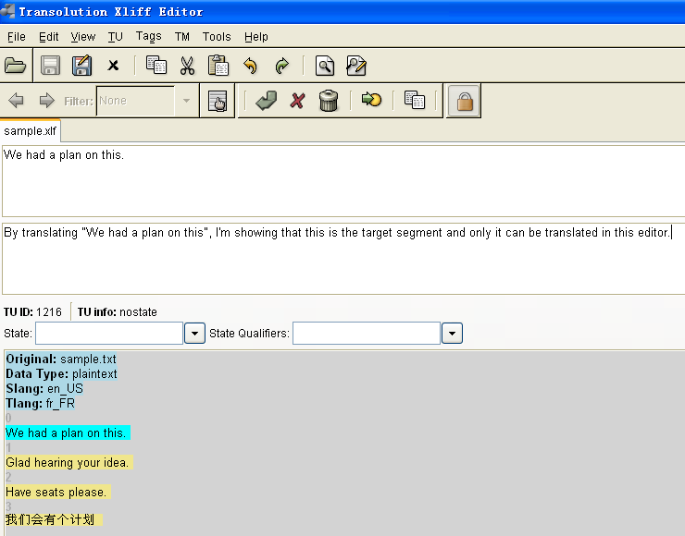

2.5 Finish translating one segment and go to next one.

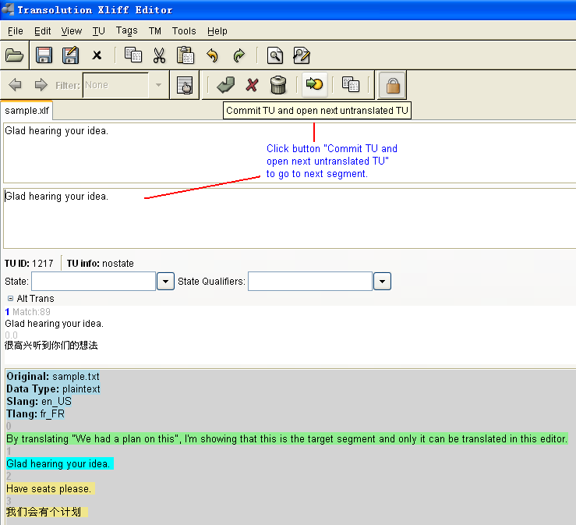

2.6 Save the translation and prepare for upload.

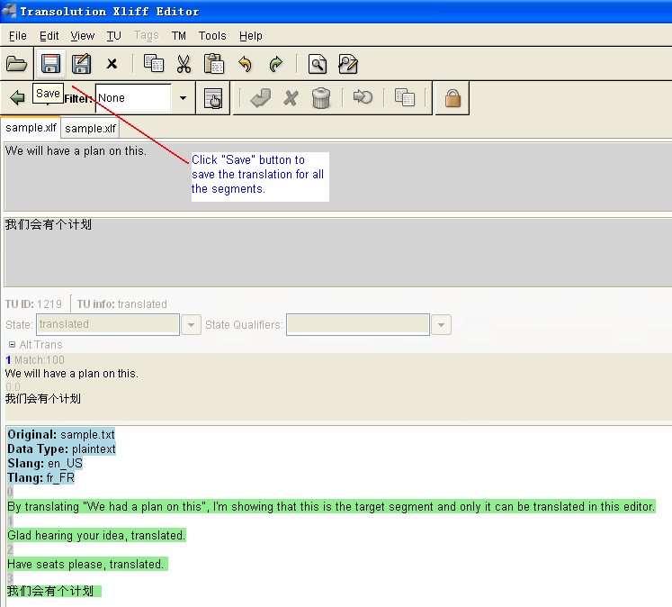

3. Upload
Go to upload page. Select the translated xliff file and click “Start Upload” button to upload.

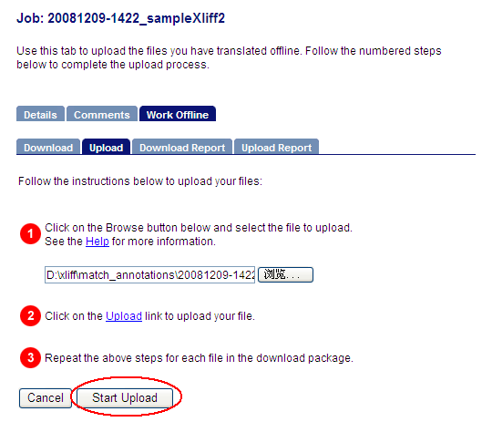

4. Verify the translation result online
After uploading is finished successfully, go to the popup editor to verify the translation result in target segments.

